VTEK2 supply connector plug

- chromed supply connector plug for vehicles
- 2 charging curcuits 12-24V DC
- 1 phase 230V AC
- pin for dissolving monitoring
- compressed air supply
- airpressure of 0-10bar, special model for 40bar
- controlling signal for "dead disconnection"
- impact-resistant and splash water protected enclosure

technical data:
- charge current: 20A DC (rated current)
- alternating curent: 12A AC (rated current)
- vehicle- air supply: 0-10 (40) bar
- dissolving- air supply: 2-6 bar
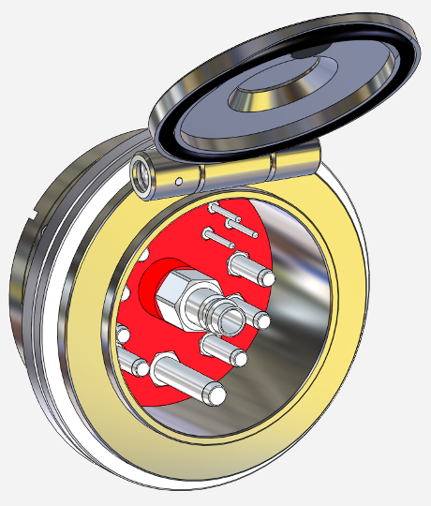
- ambient temperature: -20°C - 60°C

