VKUP1 supply coupler

- supply coupler with 5m cable (special length available)
- 2 charging curcuits 12-24V DC
- 3 phases 230/400V AC
- control lamp (shows correct air- and current- connection of the vehicle)
- built-in electronic curcuit to control the dissolving process
- separate braking- and dissolving air pipe
- built-in micro-pushbutton for manual dissolving process
- airpressure of 0-10bar, special model for 40bar
- controlling signal for "dead disconnection"
- impact-resistant and splash water protected enclosure

technical data:
- charge current: 20A DC (rated current)
- alternating curent: 12A AC (rated current)
- vehicle- air supply: 0-10 (40) bar
- dissolving- air supply: 2-6 bar
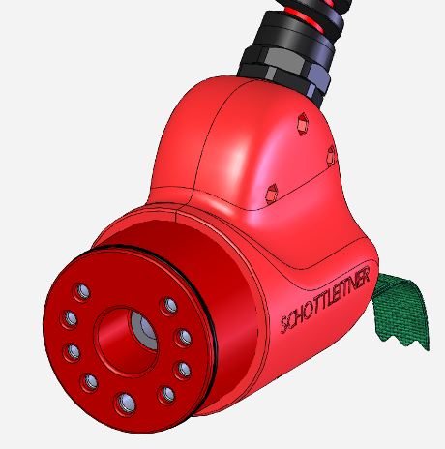
- ambient temperature: -20°C - 60°C

