Alarm device for VTEK

- shrill alarm device for the installation in vehicles
- if the vehicle get started the alarm device sounds unless the cap from VTEK is not closed
- used to protect the equipment by possibly errors
- wide voltage range
- with plug connection

technical data:

- sound level: @V_{min}: 70 dB/60 cm @V_{max}: 85 dB/60 cm
- voltage: 4 - 28 VDC
- current: 15mA
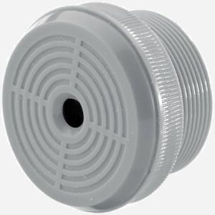
- frequency: 3,6 cont. kHz

